Water Pump Interfacing

Description:
Water Pump Interfacing is a basic electronics project that demonstrates how a submersible water pump can be controlled using a simple switch and battery. When the switch is turned ON, the circuit completes and the water pump starts pumping water. When the switch is OFF, the circuit breaks and the pump stop. This project helps understand basic circuit control and switching in electronics.
Block Diagram:
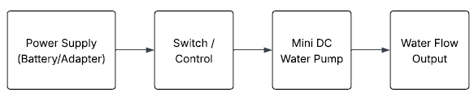
Pinout / Circuit Connection:
- 9V Battery Positive (+) → Switch
- Switch Output → Positive terminal of Water Pump
- Water Pump Negative terminal → 9V Battery Negative (GND)
Components Required:
- Submersible Water Pump (5V)
- 9V Battery
- Switch
- Connecting wires
Working Principle:
The project works on the principle of manual switching in an electrical circuit.
When the switch is turned ON, it completes the circuit and allows current from the battery to flow through the pump, causing it to run. When the switch is turned OFF, the circuit opens and current stops flowing, turning the pump OFF.

Operation (Step-by-Step):
- Connect the positive terminal of the battery to the switch.
- Connect the switch output to the positive terminal of the water pump.
- Connect the negative terminal of the water pump to the battery negative terminal.
- Turn ON the switch to start the pump.
- Turn OFF the switch to stop the pump.
Conclusion: (Predefined/self-written)
The Water Pump Interfacing project demonstrates a simple method to control a water pump using a manual switch. It is useful for understanding basic electrical circuits and switching operations and can be extended to automated systems using sensors and microcontrollers.
For Your References:
- Arduino Project Hub – Basic Electronics Projects
- Electronics Tutorials – Switch Controlled Circuits

